House Price Prediction Project

Table of Contents
- Acknowledgements
- Project Overview
- Dataset Description
- Project Structure
- Technology Stack
- Implementation Steps
- Code Explanation
- Model Development
- Deployment Process
- Results and Output
- Challenges and Solutions
- Future Enhancements
- Conclusion
- References

1. Acknowledgements
Dataset Source
- Dataset Name: House Sales in King County, USA
- Source: Kaggle -House Data dataset
- Contributor: Shreya Chaudhary
- Original Context: This dataset contains house sale prices for King County, which includes Seattle. It includes homes sold between May 2014 and May 2015.
Tools and Libraries
- Flask: Web framework for Python
- Scikit-learn: Machine learning library
- NumPy: Numerical computing
- Pickle: Model serialization
- Pandas: Data manipulation
- HTML/CSS: Frontend development
- Render: Cloud deployment platform
- Git/GitHub: Version control and hosting
Special Thanks
- Kaggle community for providing the dataset
- Open-source contributors of all libraries used
- Render platform for free deployment hosting

2. Project Overview
Objective
Develop a machine learning web application that predicts house prices based on various features such as location, size, condition, and temporal factors.
Problem Statement
Real estate prices are influenced by multiple factors that are often complex to analyze manually. This project aims to:
- Create a predictive model using historical housing data
- Build an intuitive web interface for users
- Deploy the application for public access
- Provide accurate price estimations based on input parameters
Key Features
- User-Friendly Interface: Clean, responsive web design
- Real-time Predictions: Instant price estimation
- Multiple Input Parameters: 17 different features affecting house prices
- Deployed Application: Accessible online via web browser
3. Dataset Description
Dataset Specifications
- Total Records: 21,613 houses
- Features: 18 columns
- Time Period: May 2014 to May 2015
- Location: King County, Washington, USA
Data Preprocessing Steps
- Handling Missing Values: Checked for null values
- Feature Engineering:
  - Extracted year, month, day from date
  - Encoded categorical variables (city, country)
- Feature Selection: Selected 17 most relevant features
- Normalization: Applied where necessary for model performance
5.Project structure
House-Price-Prediction/
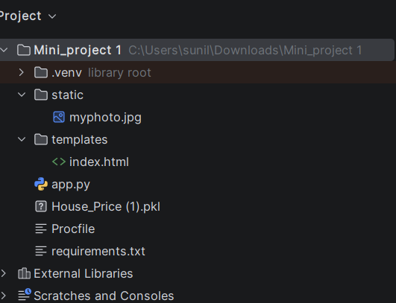

5.Technology Stack
Backend
- Python : Primary programming language
- Flask: Lightweight web framework
- Scikit-learn: Machine learning algorithms
- Pandas: Data manipulation and analysis
- NumPy: Numerical operations
- Pickle: Model serialization
Frontend
- HTML5: Markup language
- CSS3: Styling with advanced animations
Development Tools
- PyCharm: IDE for Python development
- Git: Version control system
- GitHub: Code repository hosting
- Jupyter Notebook: Interactive model development
Deployment
- Render: Cloud platform for deployment
- Pip: Python package manager
- Implementation Steps
Step 1: Environment Setup
- Create virtual environment
python -m venv venv
- Activate virtual environment
venv\Scripts\activate
- Install required packages
pip install flask numpy pandas scikit-learn gunicorn
Step 2: Data Analysis and Model Training
- Load dataset from Kaggle
- Perform exploratory data analysis (EDA)
- Preprocess data (cleaning, feature engineering)
- Split data into training and testing sets
- Train Linear Regression model
- Evaluate model performance
- Save model using pickle
Step 3: Flask Application Development
- Create app.py with Flask routes
- Load the trained model
- Create API endpoint for predictions
- Handle form submissions
Step 4: Frontend Development
- Design HTML form with all required inputs
- Style using CSS with modern animations
- Create responsive layout
Step 5: Local Testing
- Run Flask application locally
python app.py
- Access application at
http://localhost:5000
Step 6: Version Control (GitHub – Manual Method)
- Create a new public repository on GitHub
- Upload all project files directly using GitHub web interface
- Ensure files like app.py, requirements.txt, Procfile, model file, and folders are uploaded
- Copy the public GitHub repository URL for deployment use
Step 7: Deployment to Render
- Open Render Dashboard and click New → Web Service
- Select Public Git Repository and paste the GitHub repository URL
- Choose Python environment
- Render installs dependencies from requirements.txt
- Application runs using gunicorn via Procfile
- Deployment completes and a live application URL is generated

7. Code Explanation
Model Training and Evaluation (Custom Linear Regression Implementation)
This Python script implements a House Price Prediction model using custom Linear Regression, without directly using sklearn’s regression model. The entire process includes data preprocessing, feature engineering, model training, and evaluation.
1. Importing Required Libraries
import numpy as np
import pandas as pd
import sklearn
import sys
- NumPy: Used for numerical computations and matrix operations
- Pandas: Used for data loading and preprocessing
- sklearn: Used only for train–test split
- sys: Used for exception handling and debugging
2. Class Definition: MINIPROJECT
class MINIPROJECT:
This class encapsulates the entire machine learning workflow, including:
- Data loading
- Preprocessing
- Training
- Testing
3. Constructor (__init__) – Data Loading & Preprocessing
def __init__(self, data):
The constructor performs initial data preparation.
a) Load Dataset
self.df = pd.read_csv(data)
- Reads the CSV file containing house price data.
b) Date Feature Engineering
self.df['date'] = pd.to_datetime(self.df['date'])
self.df['year'] = self.df['date'].dt.year
self.df['month'] = self.df['date'].dt.month
self.df['day'] = self.df['date'].dt.day
- Extracts year, month, and day from the date column.
- Helps the model learn time-based price trends.
c) Drop Unnecessary Columns
self.df = self.df.drop(columns=["date", "statezip", "street"])
- Removes non-numerical or irrelevant columns.
4. Encoding Categorical Features
a) City Encoding (Manual Label Encoding)
city_map = {}
s = 0
for i in self.df['city']:
if i not in city_map:
city_map[i] = s
s += 1
self.df['city'] = self.df['city'].map(city_map).astype(int)
- Converts city names into numerical values.
- Each city gets a unique integer.
b) Country Encoding
self.df['country'] = self.df['country'].map({'USA': 0}).astype(int)
- Encodes country column into numeric form.
5. Feature and Target Separation
self.X = self.df.iloc[:, 1:]
self.y = self.df.iloc[:, 0]
- X → Independent features
- y → Target variable (house price)
6. Train–Test Split
from sklearn.model_selection import train_test_split
self.X_train, self.X_test, self.y_train, self.y_test = train_test_split(
self.X, self.y, test_size=0.2, random_state=42
)
- 80% data used for training
- 20% data used for testing
7. Model Training (training method)
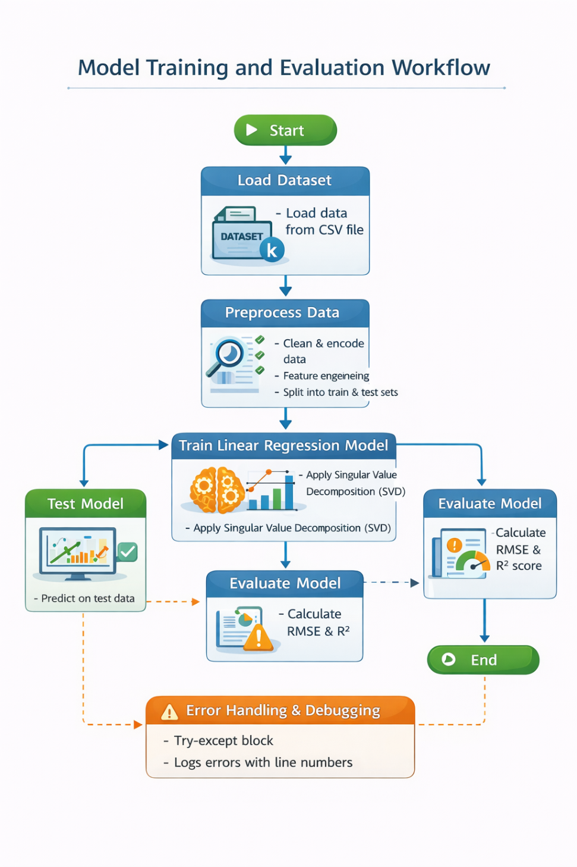
def training(self):
This method implements Linear Regression using Singular Value Decomposition (SVD).
a) Mean Centering
X_mean = self.X_train.mean().values
y_mean = self.y_train.mean()
X_centered = X_np - X_mean
y_centered = y_np - y_mean
- Centers the data to improve numerical stability.
b) Singular Value Decomposition (SVD)
U, S, Vt = np.linalg.svd(X_centered, full_matrices=False)
- Computes pseudo-inverse of the feature matrix.
c) Model Parameters Calculation
self.m = X_pinv @ y_centered
self.c = y_mean - np.dot(X_mean, self.m)
- m → Coefficients (weights)
- c → Intercept
d) Training Predictions
self.y_train_pred = self.X_train.values @ self.m + self.c
- Predicts house prices on training data.
e) Model Evaluation (Training Data)
RMSE
rmse = np.sqrt(s / len(self.y_train))
- Measures average prediction error.
R² Score
r2 = 1 - (numerator / denominator)
- Measures how well the model explains variance in prices.
8. Model Testing (testing method)
def testing(self):
- Uses learned coefficients to predict prices on unseen test data.
a) Test Predictions
self.y_test_pred = self.X_test.values @ self.m + self.c
b) Evaluation Metrics
- Test RMSE: Measures prediction error
- Test R²: Measures model generalization
9. Main Execution Block
if __name__ == "__main__":
obj = MINIPROJECT('/content/data.csv')
obj.training()
obj.testing()
- Creates an object of the class
- Trains the model
- Evaluates performance on test data
Key Components
1. Model Loading
- The trained Linear Regression model is stored in a file named MINI_PROJECT.pkl.
- This model is loaded into the Flask application using pickle.
- Loading the model allows the application to make house price predictions.
2. Flask Routes
- / (Home Route):
Displays the main web page with the input form.
- /predict (Prediction Route):
Takes the user’s input from the form, sends it to the model, and shows the predicted house price.

3. Request Processing
- request.form.values() collects all values entered by the user.
- These values are converted from string to float.
- The input data is reshaped into the correct format for the model.
4. Prediction
- model.predict() is used to predict the house price.
- The model returns a single predicted value.
- This predicted price is displayed on the web page.
HTML Form - Input Fields Mapping
The form collects 17 features that map to the model's input requirements:
- bedrooms: Number of bedrooms
- bathrooms: Number of bathrooms (can be decimal for half-baths)
- sqft_living: Living area square footage
- sqft_lot: Lot size square footage
- floors: Number of floors
- waterfront: Binary indicator (0 or 1)
- view: View quality rating (0-4)
- condition: Overall condition rating (1-5)
- sqft_above: Square footage above ground
- sqft_basement: Basement square footage
- yr_built: Year the house was built
- yr_renovated: Year renovated (0 if never)
- city: Encoded city value
- country: Encoded country value
- year: Sale year
- month: Sale month
- day: Sale day

8. Model Development
Model Selection: Linear Regression
Why Linear Regression?
- Simple and interpretable
- Works well with continuous target variables
- Low computational cost
- Good baseline model for regression tasks
Model Performance Metrics
- R² Score: Measures how well the model explains variance in the target variable
- Mean Squared Error (MSE): Average squared difference between predicted and actual values
- Root Mean Squared Error (RMSE): Square root of MSE, in same units as target variable
9. Deployment Process
Render Deployment Steps
- Create GitHub Repository
  - Initialize local git repository
  - Push all files to GitHub
- Setup Render Account
  - Sign up at render.com
  - Connect GitHub account
- Create New Web Service
  - Click "New +" → "Web Service"
  - Connect your GitHub repository
  - Configure settings:
    - Name: house-price-predictor
    - Environment: Python
    - Build Command: pip install -r requirements.txt
    - Start Command: gunicorn app:app
  - Click "Create Web Service"
- Environment Variables (if needed)
  - Add any required environment variables in Render dashboard
- Automatic Deployment
  - Render automatically builds and deploys when you push to GitHub
  - Get live URL: https://house-price-predictor.onrender.com
Files Required for Deployment
- requirements.txt: Lists all Python dependencies
- Procfile: Specifies the command to run the application
- app.py: Main Flask application file
- MINI_PROJECT.pkl: Trained model file
- templates/: HTML templates directory
- static/: Static files directory
10. Results and Output
Application Interface
- Input Form: Clean, user-friendly form with 17 input fields
- Prediction Button: Interactive button with loading animation
- Result Display: Clearly shows predicted house price with styling
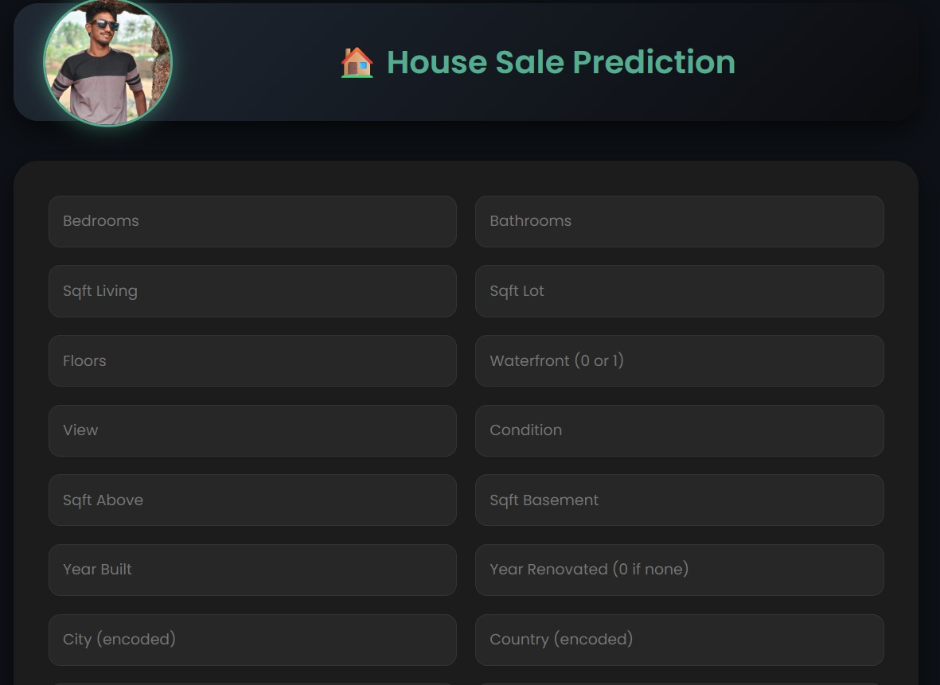
Sample Prediction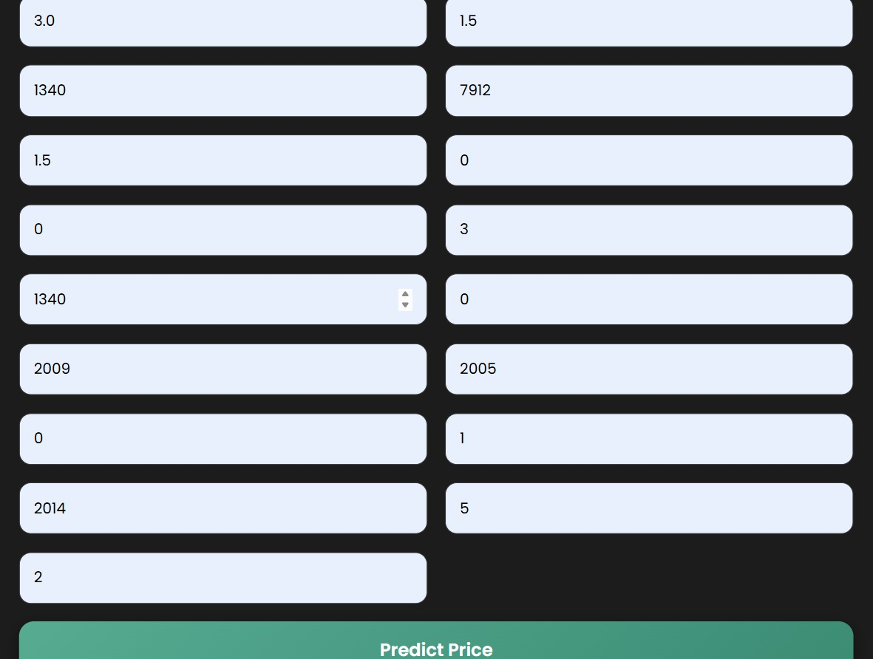
Input Values:
- Bedrooms: 4
- Bathrooms: 4
- Sqft Living: 1340
- Sqft Lot:9050
- Floors: 2
- Waterfront : 1930
- View: 1
- Condition: 1
- Sqft_above: 1900
- Sqft_basement: 2000
- Yr_built: 1200
- Yr_renovated: 1350
- City: 1
- Country: 1
- Year: 2001
- Month: 12
- Day: 1
Output:
Estimated House Price: 7.68820929
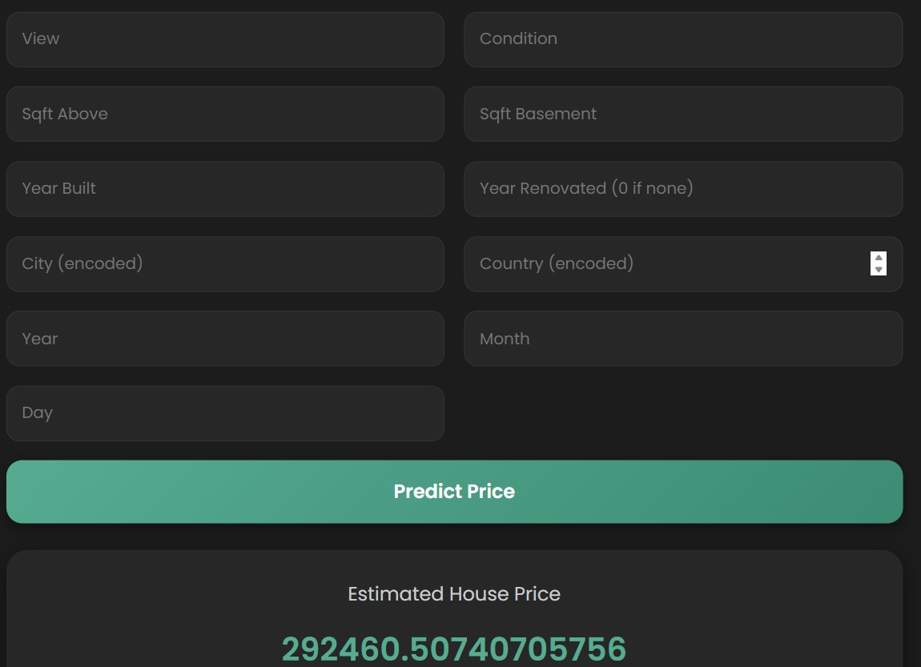
Performance
- Response Time: < 2 seconds for prediction
- Accuracy: Model-specific accuracy based on R² score
- Availability: 24/7 via Render URL
11. Challenges and Solutions
Challenge 1: Feature Engineering
Problem: Original dataset had categorical variables (city, country) that needed encoding for the model.
Solution:
- Used label encoding for categorical variables
- Extracted temporal features (year, month, day) from date
- Created new encoded features for model input

Challenge 2: Model Persistence
Problem: Trained model needed to be saved and loaded for web deployment.
Solution:
- Used Python's pickle module for model serialization
- Saved model as .pkl file
- Loaded model in Flask application
- Challenge 3: Form Input Handling
- Problem: HTML form returns string values, but model expects numerical values.
- Solution:
- Convert all form values to float
a = [float(i) for i in request.form.values()]
Challenge 4: Deployment Issues
Problem: Render deployment failed due to missing dependencies.
Solution:
- Created complete requirements.txt with exact versions
- Used gunicorn as production server
- Added Procfile for Render configuration
12. Future Enhancements
- Model Improvements
- Try Different Algorithms:
- Random Forest Regressor
- Gradient Boosting Regressor
- Neural Networks
- Feature Engineering:
  - Add polynomial features
  - Include interaction terms
  - Feature scaling and normalization

- Hyperparameter Tuning:
  - Grid Search or Random Search
  - Cross-validation for robust evaluation

Application Enhancements
- User Interface
  - Add data visualization charts
  - Include historical price trends
  - Mobile app version
- Features:
  - Save prediction history
  - Compare multiple predictions
  - Export results to PDF/Excel
- Performance:
  - Implement caching for faster predictions
  - Add API rate limiting
  - Database integration for storing predictions
Deployment Improvements
- Scalability:
  - Docker containerization
  - Load balancing for multiple instances
  - Database integration for user management
- Monitoring:
  - Add logging and error tracking
  - Performance monitoring dashboard
  - Usage analytics

13. Conclusion
This House Price Prediction project successfully demonstrates:
Achievements
- Complete ML Pipeline: From data collection to deployment
- Web Application: User-friendly interface for predictions
- Production Deployment: Live application accessible worldwide
- Documentation: Comprehensive end-to-end documentation
Key Learnings
- End-to-End Development: Experience with full-stack ML application
- Model Deployment: Practical knowledge of deploying ML models
- Web Technologies: Integration of Flask, HTML, CSS
- Cloud Deployment: Hands-on experience with Render platform
Impact
- Educational Value: Demonstrates practical ML application
- Practical Utility: Can assist in real estate price estimation
- Template: Serves as template for similar ML web applications
14. References
Documentation
- Flask Documentation: https://flask.palletsprojects.com/
- Scikit-learn Documentation: https://scikit-learn.org/stable/
- Render Documentation: https://render.com/docs
- Bootstrap Documentation: https://getbootstrap.com/docs/
Dataset
- Primary Dataset: House Sales in King County, USA

Tools and Platforms
- Development: PyCharm, Jupyter Notebook
- Version Control: Git, GitHub
- Deployment: Render
- Design: CSS Gradient Generators, Color Palette Tools

Project By: N.Sunil Kumar Reddy
Last Updated: 10-2-2026
Live Application: https://mini-project-1-2-i11k.onrender.com
GitHub Repository: https://github.com/sunilkumarreddynalluri/Mini_Project-1.git

